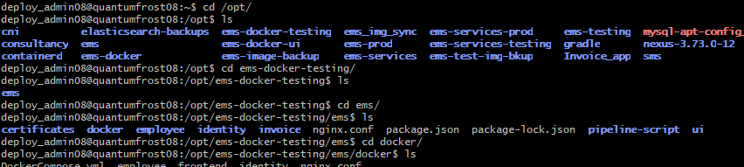
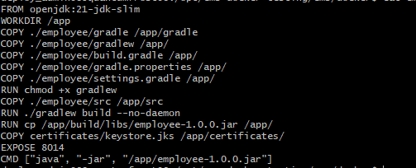

FROM openjdk:21-jdk-slim
WORKDIR /app
COPY ./employee/gradle /app/gradle
COPY ./employee/gradlew /app/
COPY ./employee/build.gradle /app/
COPY ./employee/gradle.properties /app/
COPY ./employee/settings.gradle /app/
RUN chmod +x gradlew
COPY ./employee/src /app/src
RUN ./gradlew build --no-daemon
RUN cp /app/build/libs/employee-1.0.0.jar /app/
COPY certificates/keystore.jks /app/certificates/
EXPOSE 8014
CMD ["java", "-jar", "/app/employee-1.0.0.jar"]

===========================
==============================
Identity,
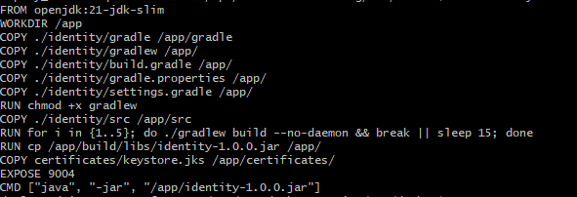

FROM openjdk:21-jdk-slim
WORKDIR /app
COPY ./identity/gradle /app/gradle
COPY ./identity/gradlew /app/
COPY ./identity/build.gradle /app/
COPY ./identity/gradle.properties /app/
COPY ./identity/settings.gradle /app/
RUN chmod +x gradlew
COPY ./identity/src /app/src
RUN for i in {1..5}; do ./gradlew build --no-daemon && break || sleep 15; done
RUN cp /app/build/libs/identity-1.0.0.jar /app/
COPY certificates/keystore.jks /app/certificates/
EXPOSE 9004
CMD ["java", "-jar", "/app/identity-1.0.0.jar"]

===========================
====================================
ui

